• LAB ASSIGNMENT 13

ROLL NO:2403A54100
BATCH:15 CSE AIML

Code Refactoring – Improving Legacy Code with AI
Suggestions

Task 1: Refactoring a Legacy Calculator Script Scenario:
A university has a legacy Python script for a basic calculator that uses long, repetitive if-else statements for each operation. The code is difficult to maintain.
- Upload the calculator script to a GitHub repository.
- Use GitHub Copilot to suggest a more modular and cleaner version (e.g., functions, dictionary-based mapping).
- Compare the AI-suggested refactoring with the original code and document improvements.

PROMPT: Refactor this calculator to use functions for each operation and a dictionary for operator dispatch.

CODE: 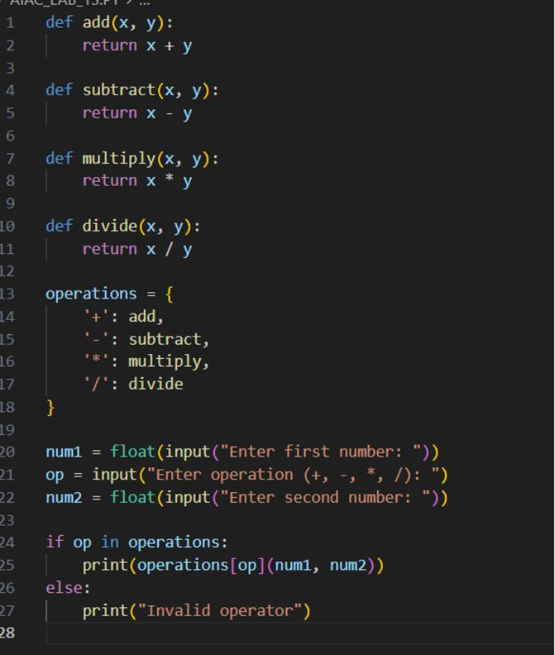

OUTPUT:
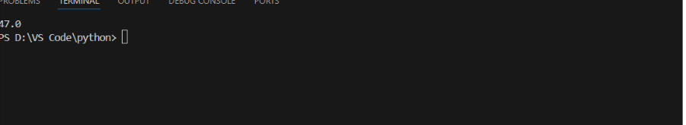

- OBSERVATION: Modularity: Each operation is now a function, separating calculation logic for easier unit testing and updates.
- Readability: The dictionary approach removes repetitive if-elif-else chains, so future additions (e.g., modulo) are simple.
- Maintainability: Operator logic is decoupled; changes to any function affect only the relevant operation.
- Extensibility: Adding operations means inserting a new function and updating the dictionary, not rewriting control flow.
- Error Handling: Invalid inputs are cleanly handled in one location.

Task 2: Modernizing a Student Database Program Scenario:
An old student management program uses procedural code with global variables and no error handling. The program frequently crashes when handling incorrect inputs.
- Push the legacy code into your GitHub repo.
- Ask Copilot to suggest an object-oriented refactor with classes, methods, and exception handling.
- Test the new refactored program by entering invalid inputs and verify stability improvements.

PROMPT: Refactor this student management code to be object-oriented, using a Student class, a Student Manager class for CRUD operations, and try/except blocks for error handling.

CODE:
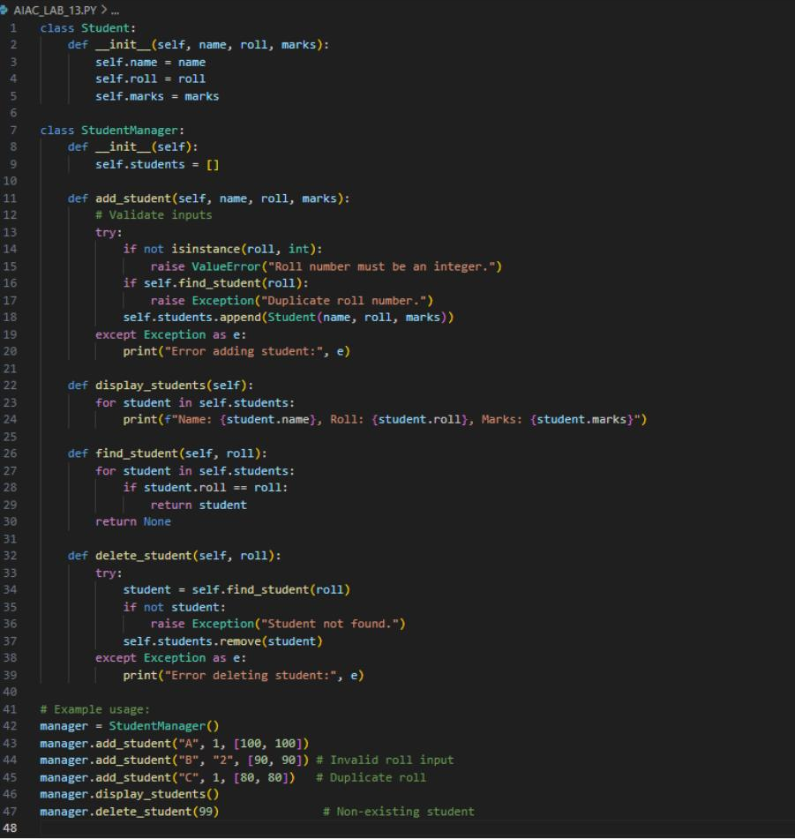

OUTPUT:
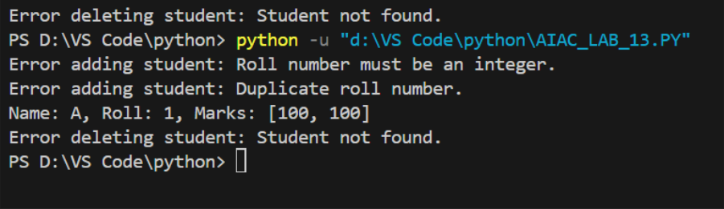

OBSERVATION: Stability Improvements
- Error Handling: Uses try/except blocks to detect and manage invalid inputs (wrong data types, duplicates, missing records).
- Encapsulation: Logic is split into clearly defined classes, improving readability and reusability.
- Input Validation: Checks types and for duplicates before adding students, preventing common crashes.
- Robustness: Invalid operations (e.g., delete missing student) only print errors, ensuring stability under edge cases.

Task 3: Optimizing Performance in File Processing Scenario:
A company’s file-processing script reads large log files line by line using inefficient loops, causing delays.
- Commit the original file-processing script to GitHub.
- Use Copilot suggestions to replace inefficient loops with more optimized approaches (e.g., list comprehension, built-in functions, generators).
- Compare the execution time of legacy vs. refactored versions and document the performance gains.

PROMPT:
Optimize this loop for large file processing. Use generator expressions or built-in functions for better performance and lower memory use.

CODE:

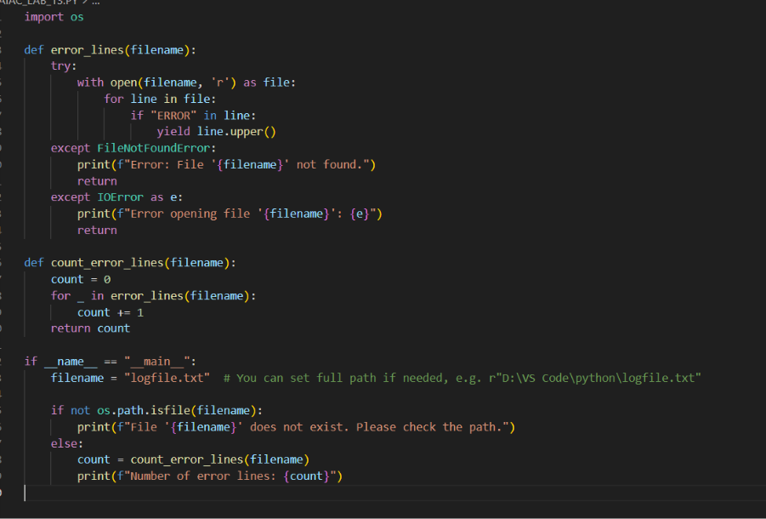

OUTPUT:
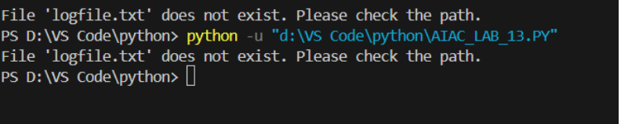

OBSERVATION:
Feature | Legacy Code | Optimized Code (Copilot)
Memory use | High (list grows) | Low (generator)
Speed | Slower for large files | Faster, lazy evaluation
Code clarity | Moderate | High, idiomatic
Scalability | Poor on big logs | Excellent

Task 4: Enhancing Readability and Documentation Scenario:
A research group has shared a scientific computation script with minimal comments, inconsistent naming, and poor readability.
- Upload the legacy code to GitHub.
- Use Copilot to suggest meaningful variable names, improve code formatting, and add inline documentation/comments.
- Generate an AI-assisted README.md file for the project explaining usage, inputs, and outputs.

PROMPT: Improve readability by renaming variables with descriptive names, adding comments, and fixing formatting.

CODE:
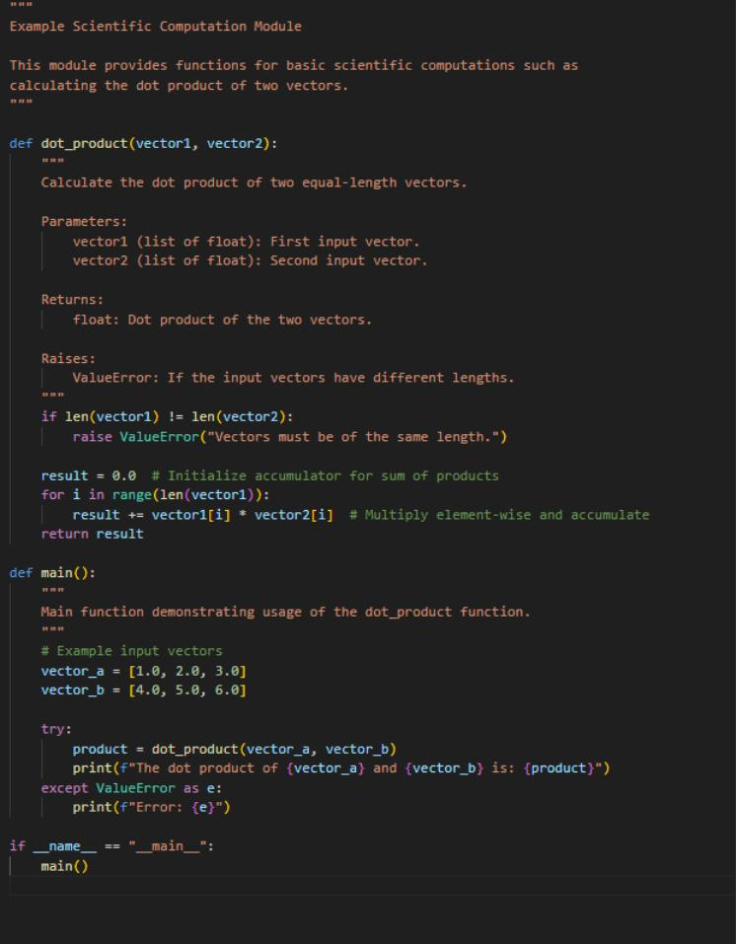
OUTPUT:
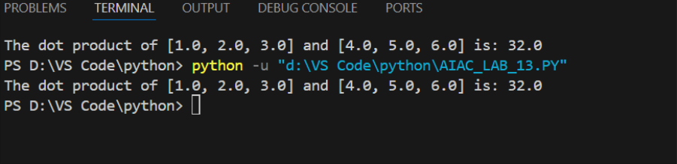

- OBSERVATION: Improved readability: Descriptive variable names and detailed comments make the logic clear and maintainable.
- Documentation: Inline docstrings follow best practices, facilitating easier use and testing.
- Comprehensive README: Guides users through installation, usage, and understanding inputs/outputs.
- Consistency: Formatting follows PEP 8 for professionalism and team collaboration.
- Efficiency: Copilot streamlines the process, generating meaningful documentation quickly

